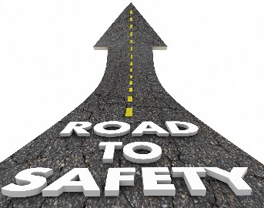Smart

Connectivity for Better Road Safety



*Presentation by*

*Gowsalya.P*



***TASK***

*IOT based Smart Connectivity for Better Road Safety*



We create a simple project related to



***OBJECTIVE***

Better Road Safety





***WORK***

*I create documentation*

*about Better Road Safety*





***IDEA***

***The projects are easy***

***understandable to everyone***

